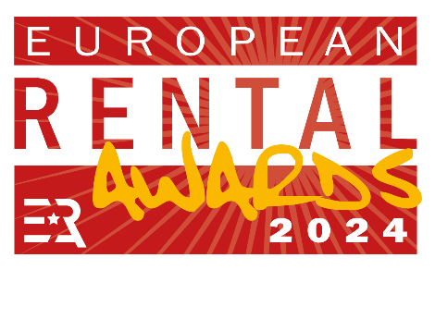

AWARDS ENTRY FORM
_____________________________________________________________________

Company:
Country:
Contact Name:
Job Title:
Tel:
E-mail:
___________________________________________________________________

Which award(s) are you entering?
Please highlight the award you are entering.

- Large Rental Company of the Year (revenues more than €15 million)
- Small Rental Company of the Year (revenues less than €15 million)
- Rental Product of the Year
- ERA Sustainability Committee Award: best emission reduction case study using rental products
- ERA/IRN Rental Person of the Year
- Lifetime Achievement Award

Send award submissions to:

Lewis Tyler, Deputy Editor, International Rental News
e-mail: lewis.tyler@khl.com Tel: +44 (0)7566 799988

DEADLINE: FRIDAY 16 FEBRUARY 2024
(Please read Guidance Notes at the end before submitting your award entries.)

AWARD ENTRY SUBMISSION

1) Please provide a 150-word summary statement explaining why your company should win this award. (For ‘Rental Person of the Year’ and ‘Lifetime Achievement’ categories, see sections 3 and 4 below.)
Please write here:

2) Please provide a supporting statement (up to a maximum of 1200 words) explaining in more detail what you have done, why you did it, and what the impact has been. Important note: The awards are for activities predominantly undertaken during 2023 and early 2024.
Please write here:

3) For the ‘ERA/IRN Rental Person of the Year’ award you can nominate a professional in the rental industry for his or her accomplishments, particularly for activities during 2023. This can be a person in your own company, or someone else.
Please write here:

4) For the ‘Lifetime Achievement Award’ you can suggest a suitable candidate for the judging panel to consider. Please provide a short outline of this person’s rental career and explain why he or she should be considered as a candidate for this special award.
Please write here:

5) In support of your entries, you can provide additional material (photos, brochures etc) up to 5 MB in size (provide details below).

6) Please supply relevant high resolution company logo/s in Jpeg or EPS format.

GUIDANCE NOTES

- Companies are invited to put themselves or their products forward for the awards. It is not necessary to get a nomination from an external company or individual. Companies can submit entries for more than one award.

- When you submit your award entry, please supply two relevant digital photos for possible use in International Rental News (IRN). (Digital photos with 300 dpi quality and at a reasonable size.) Please also include a company logo in digital format.

- The awards are for activities predominantly undertaken during 2023 and early 2024.

- The award judging criteria can be found at www.khl.com/rentalawards

- The awards are open to all companies active in Europe. Products in the ‘Product of the Year’ category must be available in Europe.

- Please submit entries and supporting materials by e-mail, up to a maximum size of 5MB.

- The judges will meet on 7 March 2024, after which the list of shortlisted companies will be announced at www.internationalrentalnews.com

- The winners will be announced at the European Rental Awards on the evening of 15 May, during the European Rental Association’s annual Convention in Lisbon, Portugal.

- Shortlisted companies will be given two free tickets for the awards. Please contact Carole Bachmann, ERA, at: CBachmann@kellencompany.com

Send award submissions to:

Lewis Tyler, Deputy Editor, International Rental News
e-mail: lewis.tyler@khl.com Tel: +44 (0)7566 799988

DEADLINE: FRIDAY 16 FEBRUARY 2024

